Science on Drupal

Configuration and Change document

ITSC Science on Drupal Configuration

|  |  |  |  |
| --- | --- | --- | --- |
| Document Type | Development Strategy with Configuration Management | | |
| **Organization** | Information Technology Systems Center | | |
| **Projects** | All | | |
| **Originator** | ITSC | | |
| **Request #** |  | **Request Type:** | Development |
| **Date** | 04/16/2014 | **Client:** | ITSC Developers |
| **Prepared by** | Rohan Bakare | **Document ID:**#1 | ITSC_science_on_drupal_configuration |

# DRUPAL-PHPSTORM SETUP

**1. Install your drupal project on REMOTE**

**- Adding the project files, giving permisssions, creating databases etc**

**REF: https://drupal.org/documentation/install/developers**

**- Copy remote to local if needed ( in case you already have a remote copy with latest modifications)**

**scp -r root@192.168.1.100:/web/autiger.itsc.uah.edu/html/custom_ubercart/* /var/www/custom_ubercart**

**2. Set up local PHPStorm editor for REMOTE code access**

**- Tools->Deployment->configuration**

**- Choose SFTP (port-22), enter remote url, login credentials**

**- add Root path just use - '/' (DO NOT Autodetect!)**

**example:**

**Name (Server) : dev.autiger.itsc.uah.edu**

**SFTP Host: 192.168.1.100**

**Local file path - C:\ITSC_VM_SHARE\web\custom_ubercart**

**Server file path - /web/autiger.itsc.uah.edu/html/custom_ubercart**

**Web path on server: custom_ubercart**

**- REF:**

**https://www.jetbrains.com/phpstorm/webhelp/creating-a-project-from-downloaded-files.html**

**https://www.jetbrains.com/phpstorm/webhelp/create-new-project-add-remote-server.html**

**- From Tools->Deployment->configuration select "AutoUpload" to enable direct sync on save from local to remote**

# PHP-XDEBUG SETUP PLUGGED IN TO REMOTE PHPSTORM

**Steps to enable remote debugging using PhpStorm and XDebug:**

**1. Open port 9000 on windows firewall (and not in VirtualBox)**

**2. load xdebug as zend extension and enable remote debugging in php.ini : /etc/php5/apache2/php.ini**

**zend_extension=/usr/lib/php5/20090626/xdebug.so**

**xdebug.remote_enable=1**

**xdebug.remote_handler=dbgp**

**xdebug.remote_host=localhost**

**xdebug.remote_port=9000**

**xdebug.remote_host=146.229.234.89 (put correct server ip where PhPstorm is running)**

**xdebug.remote_connect_back=1**

**xdebug.remote_lod=/var/log/xdebug.log**

**3. Set path mapping in PhpStorm. No need to create PHP remote debugging configuration or click on "Start listen for php debug connections"**

# UBERCART CUSTOMization CHANGE-LOG

Location: \ubercart\uc_cart\uc_cart.module  
Change:

* **$form_state to be updated for each removed item, is updated along with $start_date and $end_date**
* **Each individual updated $item also considers changes in date variables if any for sending it to the database table to be saved**

Change:

* **Cart table updated with three new columns – start_date, end_date, size**

Change:

* **Every time the item is added to the cart; and then update cart is performed, the page would need to be manually refreshed in order to reflect the earlier made changes. Ajinkya came up with this solution**

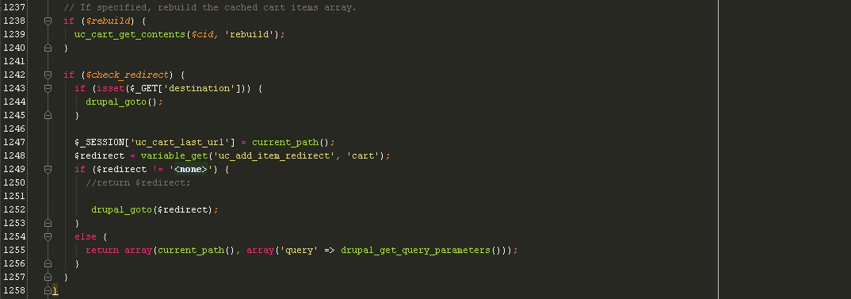

Change:

* **While invoking the module to update the item, last status of the date variables is also sent over to be considered while updating item object (new variables may incur latest changes made to the cart item)**

**uc_cart.checkout_pane.inc**Location: ubercart\uc_cart\uc_cart_checkout_pane.inc  
Change: For checkout and review pages we need to fetch the data already saved in DB table uc_cart_products and display it in table where modified the header text and row values of the cart table custom fields 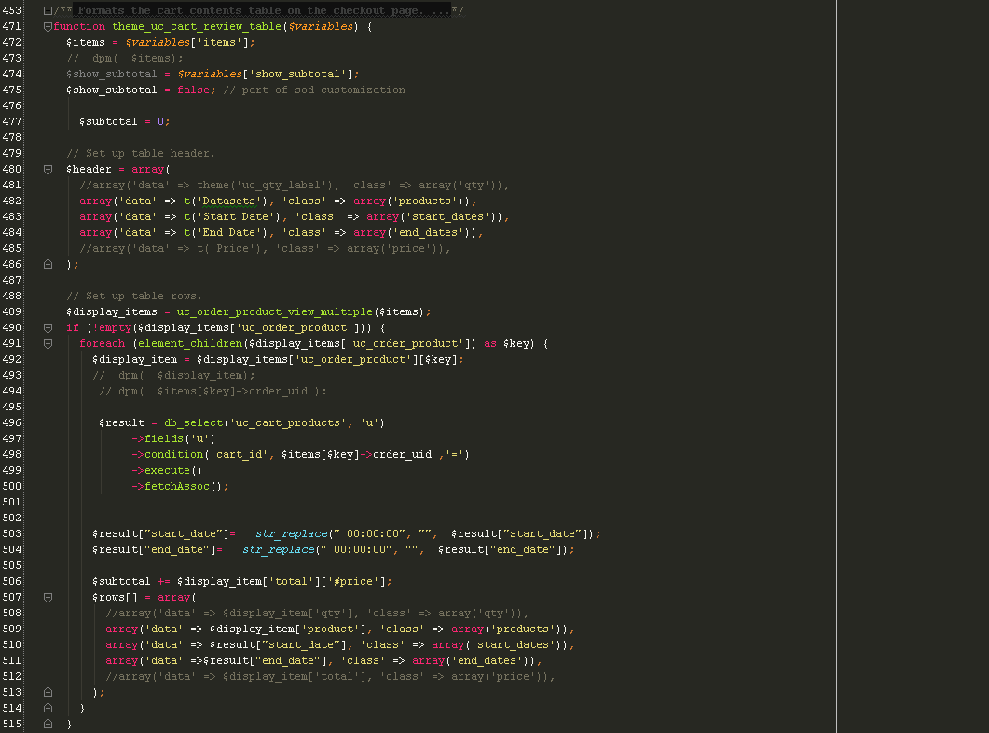

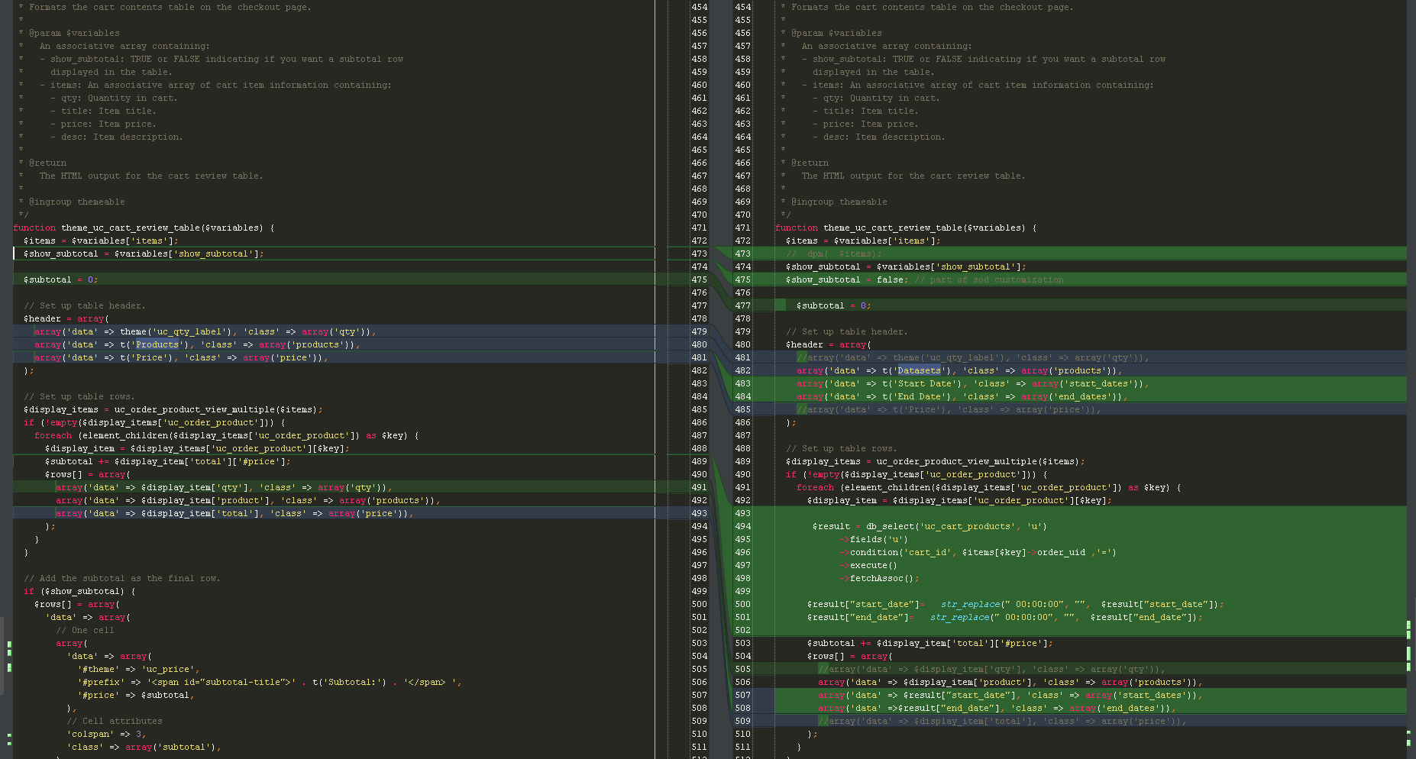

Change: set the row values of the cart table custom fields

# uc_product.module Location: ubercart\uc_product\uc_product.module Change: existing ubercart display function modified to accommodate the new date fields. The values assigned to the date fields come from the database and need formatting that matches with the date format we have used in the jQuery calendar.js code for the pop-up calendars. The default and the value are set in html for them to be accessed at front end identified by node id.

# Change: added a function to directly query solr instance to ask the start date and end date for a given dataset name. The function uses php’s curl method to fetch the solr query result over the http

# custom_cart changes Change: The purpose of developing this custom module was to implement all the custom requirements for the sod data cart. Later as the development progressed, it became impractical to keep the code in separate module, so we decided to modify in place, the existing ubercart module is customized as needed. The only remaining use of this module is to provide the pop-calendar for the start dates. It can be moved to ubercart itself under uc_cart\js\ directory. This change was not approved so its kept as is in the custom_cart. Following are two change files – 1. Location: custom_cart\custom_cart.module

2. Location: custom_cart\js\calendar.js